# ***NAME*** : *VIJAYKUMAR D*

**REG.NO: 811519104119**

# QUESTIONS & ANSWERS..,

# (1)Using Any Programming Language of your choice

Write a program in any language of your choice (C, Java, SQL Stored Procedure, Unix Shell Programming, Python). Focus on getting the logic accurate rather than 100% technically correct syntax, as evaluation is more on your ability to logically design the construct.

The problem Statement

The program takes input a short abstract and outputs the following

* prints each word in reverse.
* prints Top 2 occurring words in sorted order. The words that have occurred most of the time.

Sample Input:

"This declaration represents a political commitment among declaration partners to advance a positive vision for the Internet in this era of a united europe"

Sample Output: Printing word in reverse

“Europe of century 21st of era this in Internet the for vision positive a advance to partners declaration among commitment political a represents declaration this”

Sample Output: Occurrence of words

a : 3 times

this : 2 times

**PROGRAM:**

def word_count(str):

counts = dict()

words = str.split()

for word in words:

if word in counts:

counts[word] += 1

else:

counts[word] = 1

return counts

k = input().lower()

s=k.split(' ')

s[-1] = s[-1].capitalize()

s.reverse()

print('Printing word in reverse:')

print(*s)

print('Occurrence of words:')

dic=word_count(k)

for i in sorted(dic, key = dic.get,reverse=True):

if(dic[i]>1):

print(i,":",dic[i])

**sample output:**

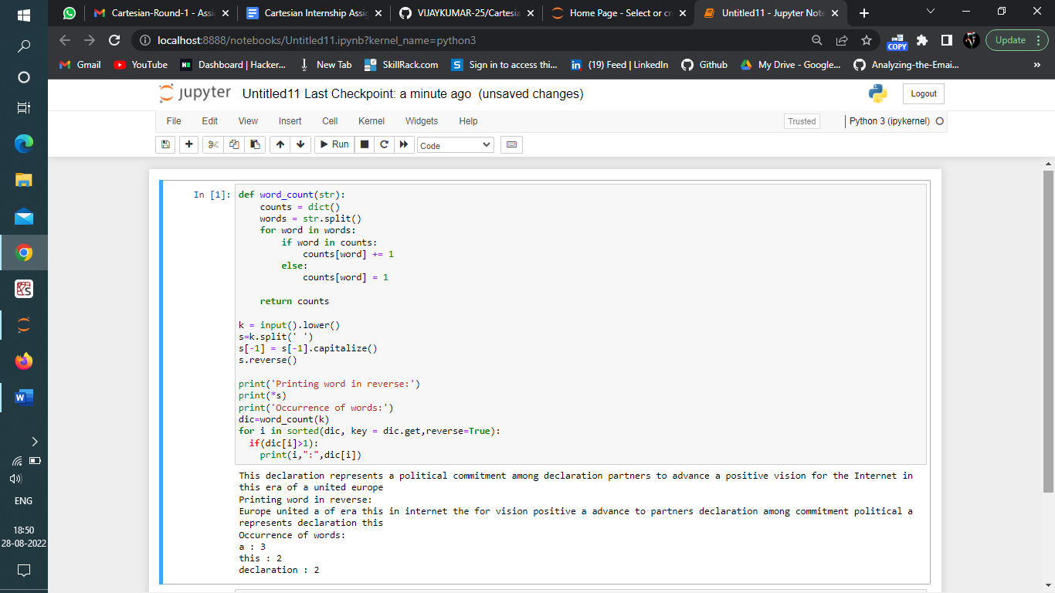

# (2) Assignment Using SQL

## (i) ASSIGNMENT-01SQL

Please refer to two tables of Appendix A – Purchase History and Product Catalogue. Purchase History contains all purchases done for Grocery Store. Product Catalogue contains all product and its category.

Develop a SQL query that will find out two Products for each product category that are most popular in last 30 days. Popularity is based on maximum quantity sold in a particular category.

Sample Input:

Refer to Table in Appendix A

Sample Output:

|  |  |  |
| --- | --- | --- |
| Cat_Id | Product_Id | Trending |
| 1 | 100 | 1 |
| 1 | 200 | 2 |
| 2 | 300 | 1 |
| 2 | 301 | 2 |

## 

**SQL QUERY:**

**SELECT customer_id,MAX(purch_amt)**

**FROM orders**

**GROUP BY customer_id;**

## (ii) ASSIGNMENT-02SQL

There is a Customer Table having a single column with list of customer id. There is a Voucher table having a single column with list of voucher ids.

Develop a query that will assign one voucher to one customer and vice versa. Two customers will not get same voucher. Two Voucher will not be assigned to a single customer.

Sample Input

|  |
| --- |
| Customer_Id |
| Abhinash |
| Vipin |
| Mahesh |
| Bijoy |
| Bhabani |
| Ashutosh |

|  |
| --- |
| Voucher_Id |
| ABXFH |
| SDFGH |
| ERTYY |
| PPLKM |

**SQL QUERY:**

**CREATE TABLE Customer (Customer_Id varchar(255));**

**INSERT INTO Customer VALUES('Customer_Id'),('Abhinash'),('Vipin'),('Mahesh'),('Bijoy'),('Bhabani'),('Ashutosh')**

**CREATE TABLE Voucher (Voucher_Id varchar(255) UNIQUE);**

**INSERT INTO Voucher VALUES('ABXFH'),('SDFGH'),('ERTYY'),('PPLKM')**

**;with cte**

**as(select *,row_number() over(order by Customer_Id) rr from Customer)**

**,cte2 as(select *,row_number() over(order by Voucher_Id) rr from Voucher)**

**select Customer_Id Customer_Key,Voucher_Id Gift_Voucher_Key**

**from cte c1**

**join cte2 c2 on c1.rr=c2.rr**

# ------------------------------------------------------------------------------

# Assignment Using Unix Shell Programming (Optional)

## ASSIGNMENT-01UNIX

There is a data file containing purchase history data. Write a script to find out list of unique dates on which there are sales.

Sample Input :.

***Product, Customer, Date, Category, amt***

*Nylon V Neck, Rakesh, 2020-01-02, Shirt,799.00*

*Nylon Y Neck, Ramesh, 2020-01-02, Shirt,799.00*

*Nylon Z Neck, Rajesh, 2020-01-02, Shirt,899.00*

*Nylon Z Neck, Rajesh, 2020-01-03, Shirt,699.00*

Sample Output

*2020-01-02*

*2020-01-03*

***Unix Scripts:***

***# Script to find unique species in csv files where species is the second data field***

***# This script accepts any number of file names as command line arguments***

***# Loop over all files***

***for file in $@***

***do***

***echo "Unique $file:"***

***# Extract order names***

***cut -d , -f 2 $file | sort | uniq***

***done***

*-------------------------------------------------------------------------------------------------------------------*

## (ii)ASSIGNMENT-02UNIX

There is a folder that contains everyday purchase history of a Grocery store. There is one file for each day and all files has same format. All files have a header.

Write a unix shell script to merge all files into one file. Merged files must have only 1 header.

Sample Input

*/home/grocery/purchase_history_02Jan21.txt*

*/home/grocery/purchase_history_03Jan21.txt*

*/home/grocery/purchase_history_31Jan21.txt*

Sample Output

*/home/grocery/purchase_history_JanAll.txt*

**UNIX SHELL SCRIPTS:**

function concat_with_header() {

# Quoted suffix to pattern match for concatenation (e.g. '*.csv')

local suffix="${1}"

# Name of the output file

local output="${2:-combined.out}"

# Number of lines to use for the header

local header_length="${3:-1}"

# Grab the header from the first file

local header=`echo -e "$(ls -b *$suffix | head -n$header_length)"`

head -1 $header_file > $output; tail -n +"`expr $header_length + 1`" -q *$suffix >> $output

}

*------ ----------------- * -------------------- * ---------------- * ---------------------------*